**INDEX**

Title Page No

1. Abstract………………………………………………………………………………….02

2. Introduction………………………………………………………………………………03

3. Program Code…………………………………………………………………………….04

4. Conclusion………………………………………………………………………………32

5. References……………………………………………………………………………….33

**Abstract-:**

The process of managing the blood bag that is received from the blood donation events needs a proper and systematic management. The blood bag must be handled with care and treated thoroughly as it is related to someone’s life. The development of Web-based Blood Bank Management System (BBMS) is proposed to provide a management functional to the blood bank in order to handle the blood bag. In Kuala Terengganu, East Peninsular Coast of Malaysia has only one government hospital that handles blood bank currently is using a standalone system. This web-based management system was developed to meet the requirements for Sultanah Nur Zahirah Hospital (HSNZ). Other hospital may have different ways and approach of handling blood bag.

**Introduction-:**

Blood bank is a place where blood bag that is collected from blood donation events is stored in one place. The term “blood bank” refers to a division of a hospital laboratory where the storage of blood product occurs and where proper testing is performed to reduce the risk of transfusion related events (Vikas Kulshreshtha, Sharad Maheshwari).

Pathology Department is one of the most important departments in Sultanah Nur Zahirah Hospital (HSNZ). It processes blood that will be supplied to the patients in HSNZ according to their needs. Before the blood is supplied to the patients, the blood will undergo several tests to ensure that the blood receiver is not infected by serious diseases. There are a few units operating in this department such as Blood House Unit, Blood Transfusion Unit, and Blood Distribution Unit.

Blood Bank Management System (BBMS) is a web based system that can assists the information of blood bag during its handling in the blood bank. With this system, the user of this system can key in the result of blood test that has been conducted to each of the blood bag received by the blood bank. The result of test will indicate whether the blood bag can be delivered to patient or not.

From this system, there are several type of report that can be generated such as blood stock report, donor’s gender report and the total of blood donation according to months and year. The system also can give the information to the donor about blood analysis test result for each time the donor makes contribution. Hence, BBMS will make the blood bank stock more systematic and manageable.

**Program code-:**

**Main -:**

<html>

<head>

<style>

body {

background: url(b2.jpg) no-repeat;

background-size: cover;

font-family: Arial, Helvetica, sans-serif;

}

.registerbtn {

background-color: black;

color: white;

padding: 16px 20px;

width: 50%;

}

.signin {

text-align: center;

}

</style>

<script language="javascript" type="text/javascript">

function validation1()

{

if(document.form1.name.value=="")

{

alert("Enter Name")

document.form1.name.focus()

return false

}

if(document.form1.add.value=="")

{

alert("Enter Address")

document.form1.add.focus()

return false

}

if(document.form1.city.value=="")

{

alert("Enter city")

document.form1.city.focus()

return false

}

if(document.form1.phoneno.value=="" || isNaN(document.form1.phoneno.value) || document.form1.phoneno.value.length!=10 )

{

alert("Enter Mob No")

document.form1.phoneno.focus()

return false

}

if(document.form1.pincode.value=="" || document.form1.pincode.value.length!=6 )

{

alert("Enter Pincode")

document.form1.pincode.focus()

return false

}

var email = document.form1.mailid.value;

atpos = email.indexOf("@");

dotpos = email.lastIndexOf(".");

if (email == "" || atpos < 1 || ( dotpos - atpos < 2 ))

{

alert("Please enter correct email ID")

document.form1.mailid.focus() ;

return false;

}

if(document.form1.psw.value=="")

{

alert("Please enter correct password")

document.form1.psw.focus() ;

return false;

}

if(document.form1.ConfirmPass.value!=document.form1.psw.value || document.form1.ConfirmPass.value=="")

{

alert("Please enter correct password")

document.form1.ConfirmPass.focus() ;

return false;

}

Else

{

alert(" Registered successfully!")

return true

}

}

function show()

{

window.open("login.html");

}

</script>

</head>

<body>

<center>

<form action="" name="form1" method="POST" onsubmit="return validation1()" >

<b><h1>Register</h1>

<h2>Blood bank Management</h2>

<br>

Name:

<input type="text" name="name" placeholder="Your name.."><br><br>

Address:

<input type="text" name="add" placeholder="Your Address.."><br><br>

City:

<input type="text" name="city" placeholder="Your City."><br><br>

Pin-Code: <input type="text" name="pincode" placeholder="Your Pincode."><br><br>

Email:

<input type="text" name="mailid" placeholder="Your Email."><br><br>

Mobile NO:

<input type="text" name="phoneno" placeholder="Your Mobile No."><br><br>

Password

<input type="password" placeholder="Enter Password" name="psw"><br><br>

Repeat Password

<input type="password" placeholder="Repeat Password" name="ConfirmPass"><br><br>

<h3> <button type="submit" class="registerbtn" onclick="show()" >Register</button><h3>

<div class="signin"> <p>Already you registered? <a href="login.html">Sign in</a>.</p></div>

</center>

</form>

</body>

</html>

Output-:

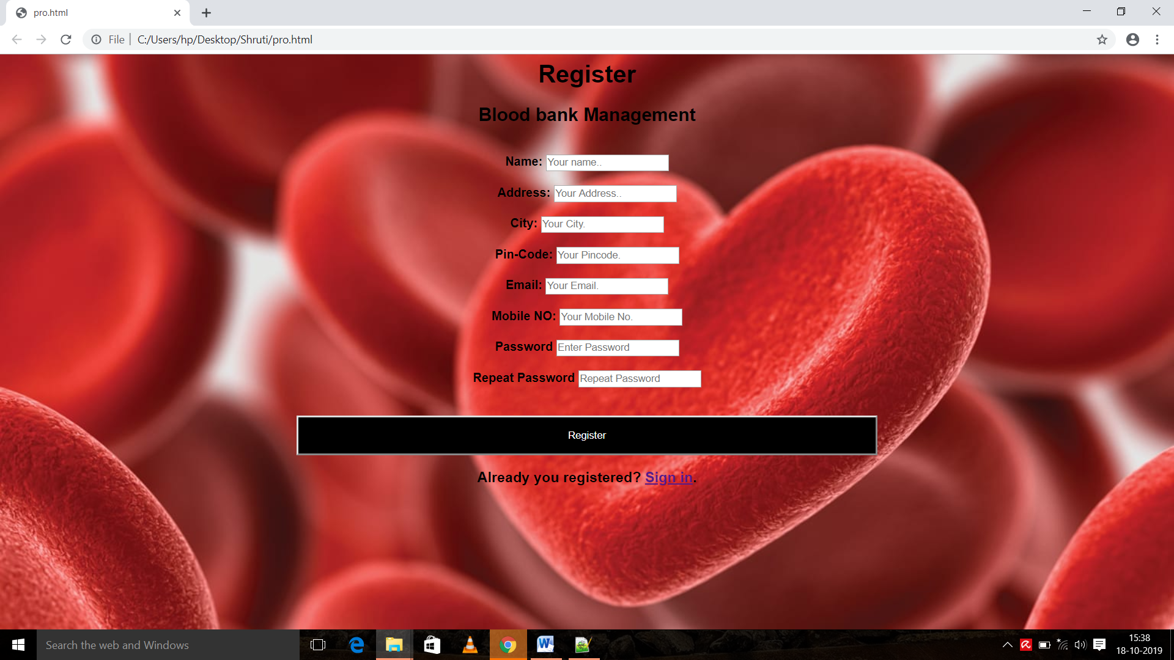

**Login Page-:**

<html>

<head>

<style>

body {

background: url(b7.jpg) no-repeat;

background-size: 100% 100%;

font-family: Arial, Helvetica, sans-serif;

}

.login{

width: 280px;

position: absolute;

top: 40%;

left: 50%;

transform: translate(-50%,-50%);

}

</style>

<script>

function login1()

{

if(document.form1.txt1.value!="tyco")

{

alert("Please enter correct username")

document.form1.txt1.focus() ;

return false;

}

if(document.form1.txt2.value!="1234")

{

alert("Please enter correct password")

document.form1.txt2.focus() ;

return false;

}

alert(" Login successfully!")

}

</script>

</head>

<body>

<form name="form1" onsubmit="return login1()" action="pro3.html">

<center>

<div class="login">

<h1><b>Login</b></h1>

Username:<input type="text" name="txt1"><br><br>

Password:<input type="Password" name="txt2"><br><br>

<input type="submit" value="Login" name="b1">

</div>

</center>

</form>

</body>

<html>

Output-:

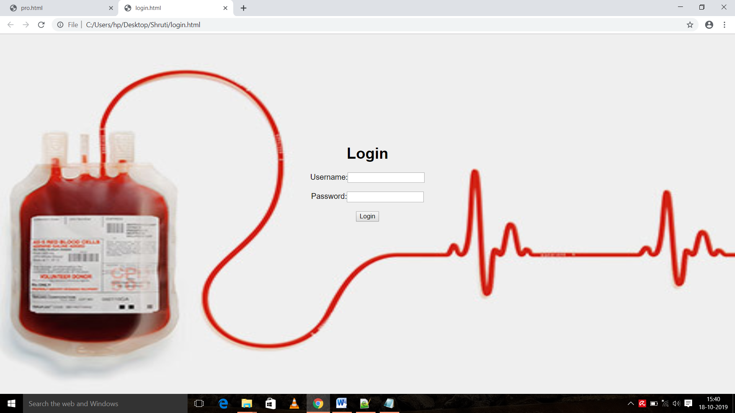

**Frame Page-:**

<html >

<head>

<title>blood management</title>

</head>

<frameset rows="15%,85%">

<frame src="frame2.html" name="f1">

<frameset cols="30%,70%">

<frame src="frame1.html" name="f2">

<frame src="frame3.html" name="f3">

</frameset>

</frameset>

<body>

</body>

</html>

Output-:

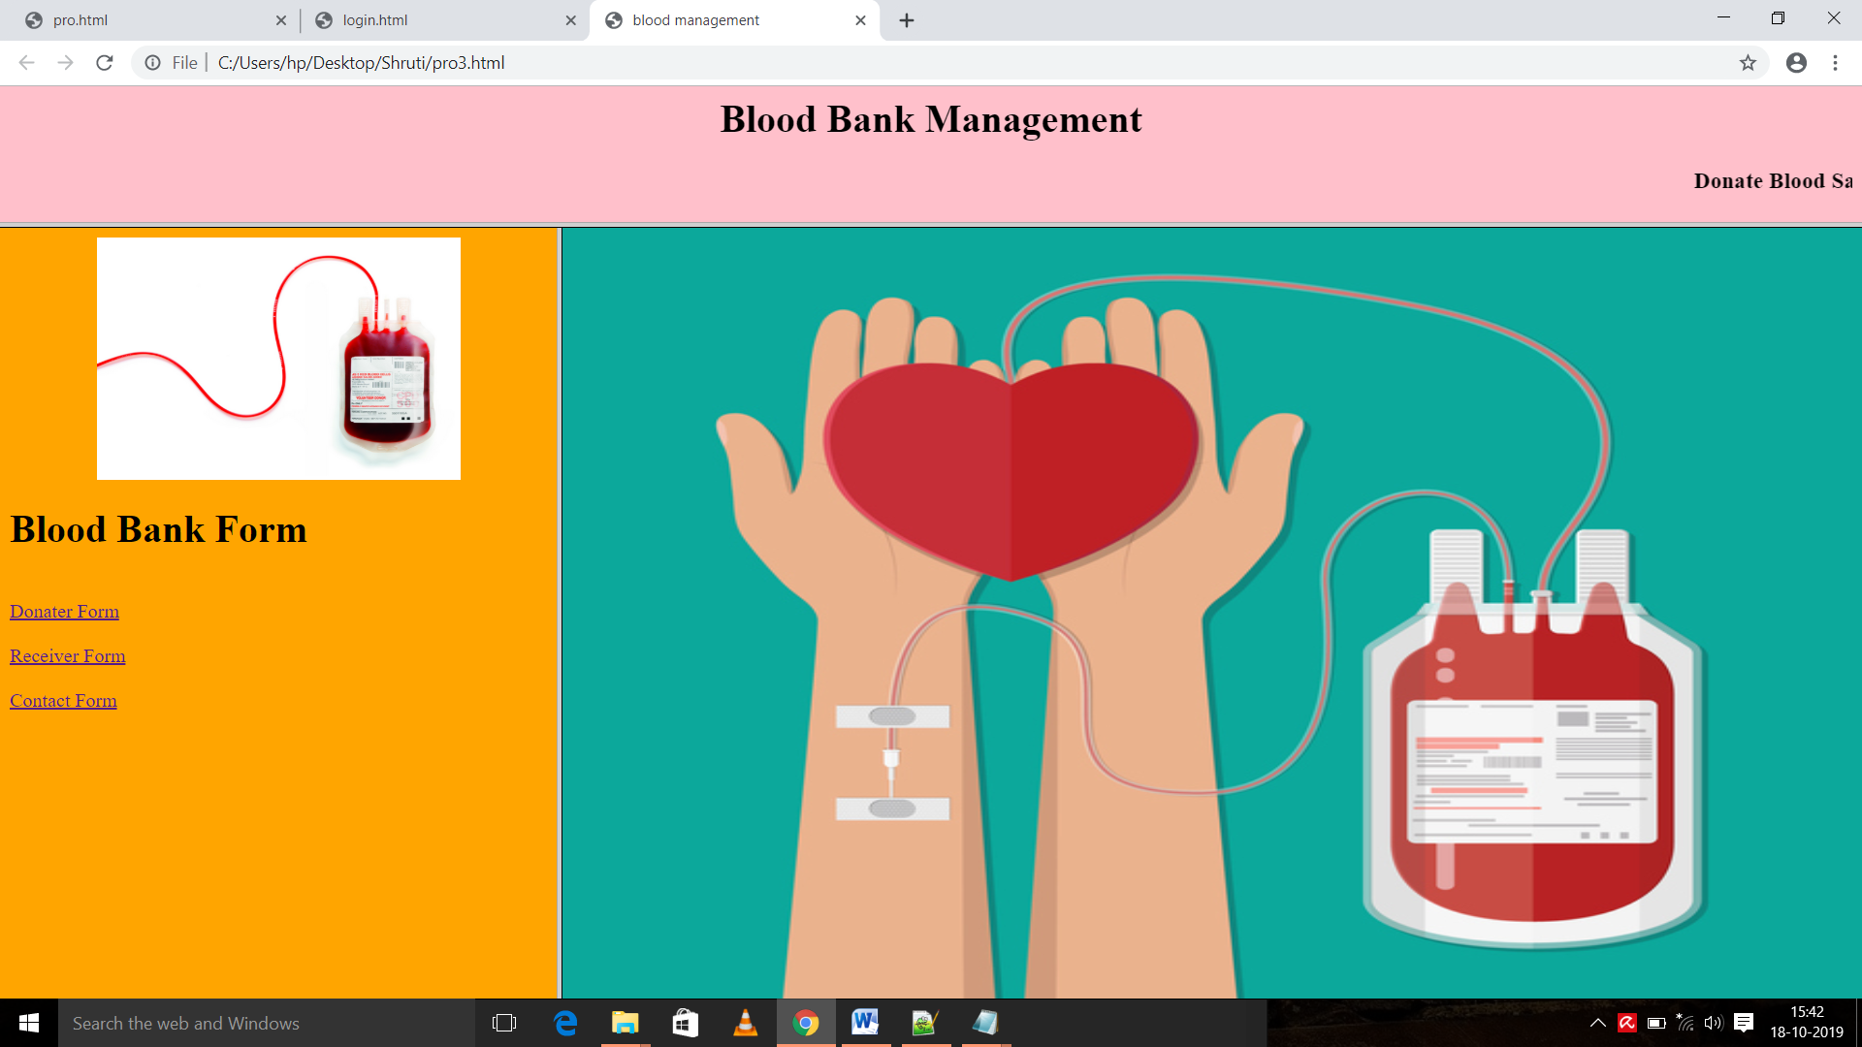

**Donar Page-:**

<html>

<head>

<title>donater</title>

<style>

body {

background: url(b3.jpg) no-repeat;

background-size: 100% 100%;

font-family: Arial, Helvetica, sans-serif

}

.login{

width: 280px;

position: absolute;

top: 40%;

left: 50%;

transform: translate(-50%,-50%);

}

.registerbtn {

background-color: black;

color: white;

padding: 16px 20px;

width: 30%;

}

</style>

<script language="javascript" type="text/javascript">

function validation1()

{

if(document.form1.name.value=="")

{

alert("Enter Name")

document.form1.name.focus()

return false

}

if(document.form1.add.value=="")

{

alert("Enter Address")

document.form1.add.focus()

return false

}

if(document.form1.phoneno.value=="" || isNaN(document.form1.phoneno.value) || document.form1.phoneno.value.length!=10 )

{

alert("Enter Mob No")

document.form1.phoneno.focus()

return false

}

}

function show1()

{

window.open("thank.html");

}

</script>

</head>

<body>

<center>

<form action="" name="form1" method="POST" onsubmit="return validation1()" >

<div class="login">

<b><h1>Donater Form</h1></b>

<br>

Name:

<input type="text" name="name" placeholder="Your name.."><br><br>

Address:

<input type="text" name="add" placeholder="Your Address.."><br><br>

Mobile NO:

<input type="text" name="phoneno" placeholder="Your Mobile No."><br><br>

Blood Group:

<input type="text" placeholder="Blood Group" name="bg"><br><br>

having Diabetes

<input type="radio" name="bgd" value="yes">Yes

<input type="radio" name="bgd" value="no">No <br><br>

!!!!Diabetes Patient do Not Donate Blood!!!!

<h3> <button type="submit" class="registerbtn" onclick="show1()" >Submit</button><h3>

</center>

</form>

</div>

</body>

</html>

Output-:

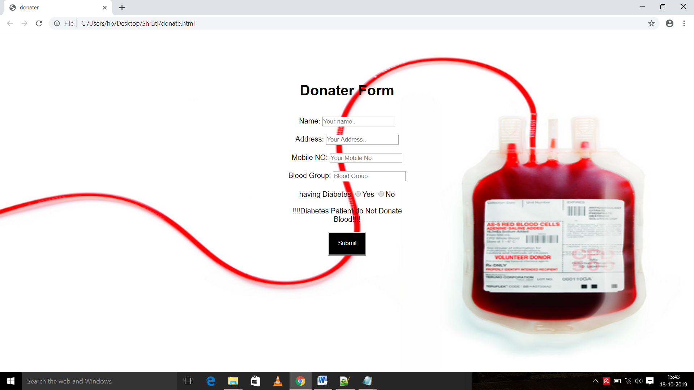

**Reciver code-:**

<html>

<head>

<title>receiver</title>

<style>

body {

background: url(b6.jpg) no-repeat;

background-size: 100% 100%;

font-family: Arial, Helvetica, sans-serif

}

.login{

width: 350px;

position: absolute;

top: 40%;

left: 50%;

transform: translate(-50%,-50%);

}

.registerbtn {

background-color: black;

color: white;

padding: 16px 20px;

width: 30%;

}

</style>

<script language="javascript" type="text/javascript">

function validation1()

{

if(document.form1.name.value=="")

{

alert("Enter Name")

document.form1.name.focus()

return false

}

if(document.form1.add.value=="")

{

alert("Enter Address")

document.form1.add.focus()

return false

}

if(document.form1.phoneno.value=="" || isNaN(document.form1.phoneno.value) || document.form1.phoneno.value.length!=10 )

{

alert("Enter Mob No")

document.form1.phoneno.focus()

return false

}

}

function show1()

{

window.open("thank.html");

}

</script>

</head>

<body>

<center>

<form action="" name="form1" method="POST" onsubmit="return validation1()" >

<div class="login">

<b><h1>Receiver Form</h1></b>

<br>

Name:

<input type="text" name="name" placeholder="Your name.."><br><br>

Address:

<input type="text" name="add" placeholder="Your Address.."><br><br>

Mobile NO:

<input type="text" name="phoneno" placeholder="Your Mobile No."><br><br>

Blood Group:

<input type="text" placeholder="Blood Group" name="bg"><br><br>

Quantity of blood:

<input type="text" placeholder="in millilitre" name="quan"><br><br>

<h3> <button type="submit" class="registerbtn" onclick="show1()" >Submit</button><h3>

</center>

</form>

</div>

</body>

</html>

Output-:

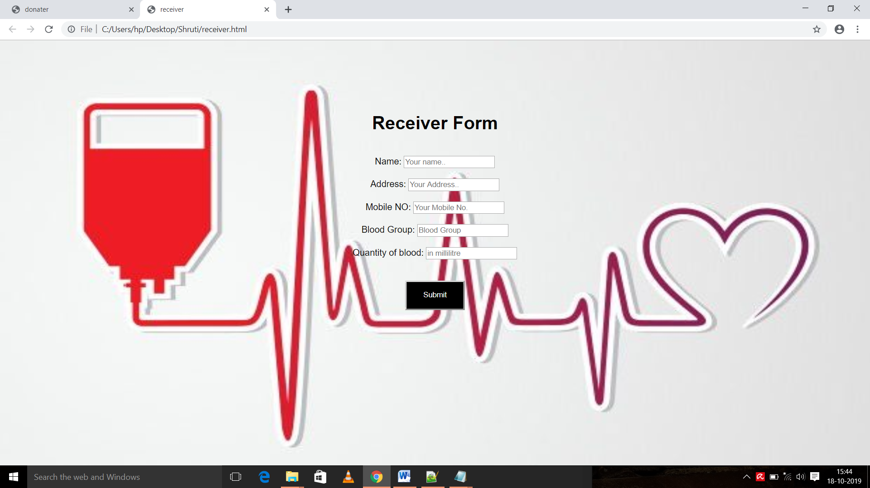

**Contact Form-:**

<html >

<head>

<title>contact</title>

<style>

body {

background: url(b7.jpg) no-repeat;

background-size: cover;

font-family: Arial, Helvetica, sans-serif;

}

</style>

<script type="text/javascript">

function yes()

{

alert("CONTACT DETAILS ARE SUBMITTED");

}

function back()

{

window.open("pro3.html");

}

function enter_the_system()

{

window.open("pro.html");

}

</script>

</head>

<body>

<center> <h1>Blood Bank Management</h1><br>

<h2>Contact Form</h2>

<div class="container">

<center>

<form name="form" action="post" target="f3">

<h3>First Name:-<input type="text" id="fname" name="firstname" palceholder="Your first name" required>

<br> <br> <br>

Last Name:-<input type="text" id="lname" name="lastname" palceholder="Your last name" required><br> <br> <br>

Mobile:-<input type="text" id="mob" name="mobile" palceholder="mobile no." required><br> <br> <br>

Country:-<select id="country" name="country">

<option value="india">India</option>

<option value="austrolia">AUSTROLIA</option>

<option value="usa">USA</option>

<option value="s africa">SOUTH AFRICA</option>

</select>

<br><br> <br><center>

<input type="submit" value="SUBMIT" onclick=yes()>&nbsp;&nbsp;&nbsp;&nbsp;&nbsp;

<input type="submit" value="EXIT" onclick="enter_the_system()">&nbsp;

</center>

</form>

<br><br><br>

</center>

</body>

</html>

Output-:

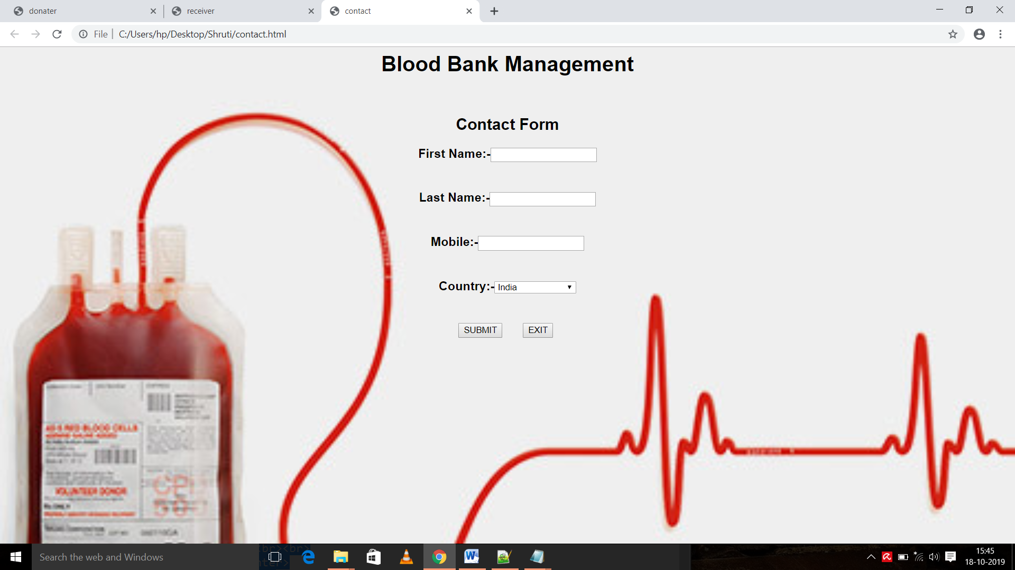

**Conclusion**

BBMS is a management system that is developed to manage blood bank in HSNZ. The BBMS had been developed in accordance to HSNZ user requirement. This is to make sure that the management of the blood stock became effective, systematic and meeting user requirements. The functional services provided in the current version are profile management, blood stock management, and blood analysis management. In the next phase we will develop a portable and modified BBMS version based on android OS. The modified version will include a user self monitoring health profile history.

**References-:**

Vikas Kulshreshtha, Sharad Maheshwari. (2011).”Blood Bank Management Information System in India”, *International Journal of Engineering*, *1,2,* 260-263.

www.ibm.com/developerworks/rational/.../1251_bestpractices